**PROJECT REPORT**

**Linear Regression :- Machine Learning model with multiple variables**

**Aim of the Project :-**

Making a linear regression model that could appropriately predict the probability of admission to a university of particular rating based on the GRE score , TOESL score , CGPA and SOP of the student.

**Role of various factors taken along each column:-**

Various factors along x axis such as GRE score , TOEFL score , SOP and CGPA play a vital role in the selection of a student for any university of a particular rating.

Along y axis probability of admission is measured against each depending factor separately and then finally combined to unified form.

1. **Relation between probability of admission and GRE score of student**

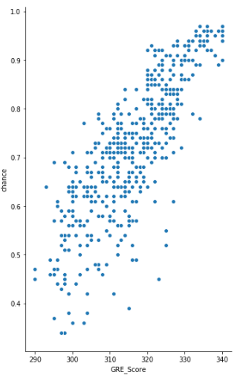

1. **Relation between probability of admission and TOEFL score of student**

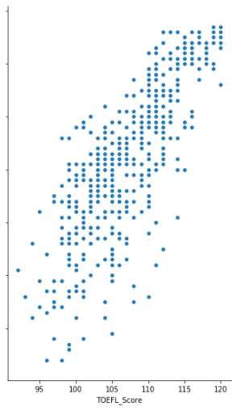

1. **Relation between probability of admission and rating of university**

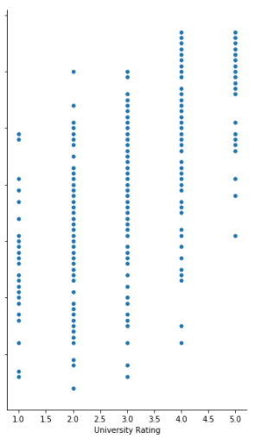

1. **Relation between probability of admission and CGPA of student**

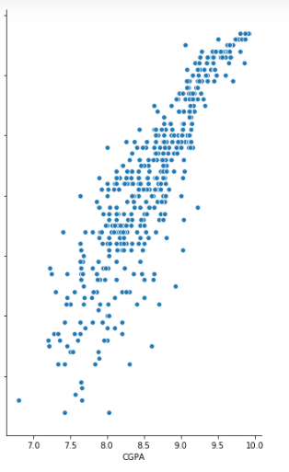

1. **Relation between probability of admission and SOP of student**

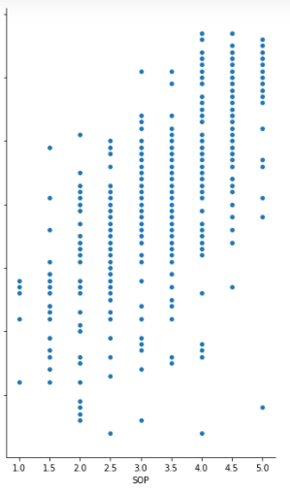

**Heat map visualization of different parameters and admission of probability**

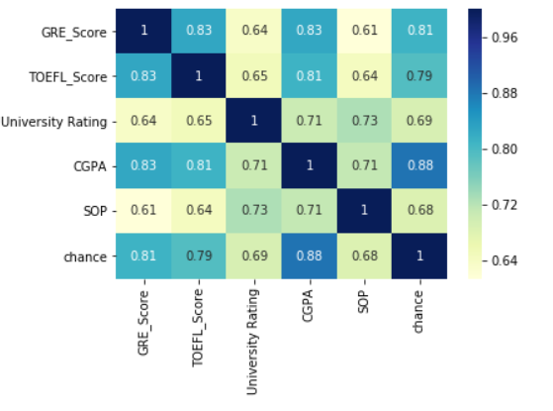

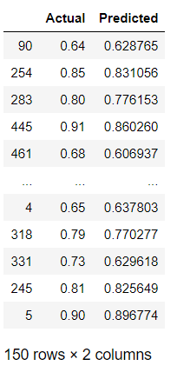**Comparing the actual and the predicted data**

**Conclusion:-**

A linear regression of model was created which predicted the admission probability with the accuracy of 95.5 percent.

**Submitted by**

**Yash Pritwani**

**Branch – CSE**